The if statement can contain a if-else statement inside another if or else-if statement.

Syntax:

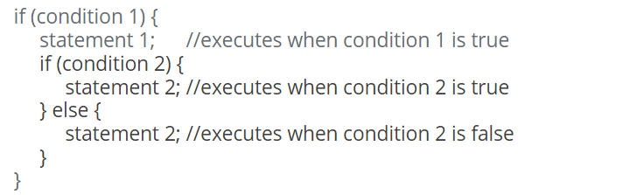

Example:



**Also, the above code can be written using ternary operators as:**

